**The basic logic of the game**

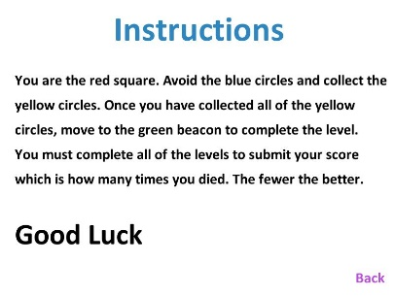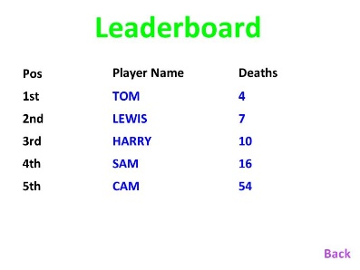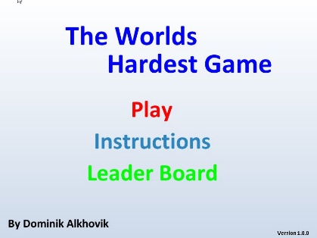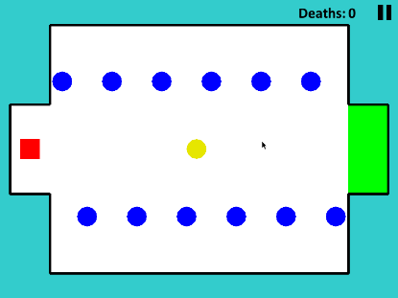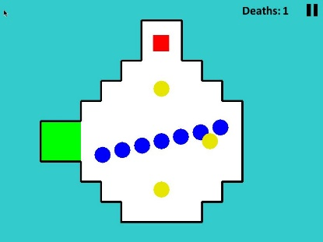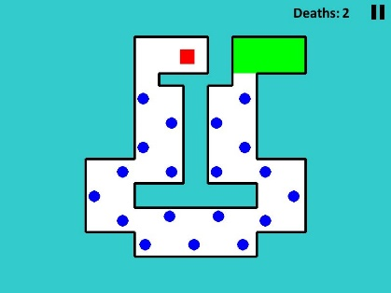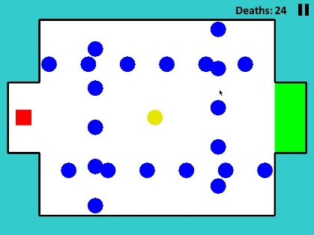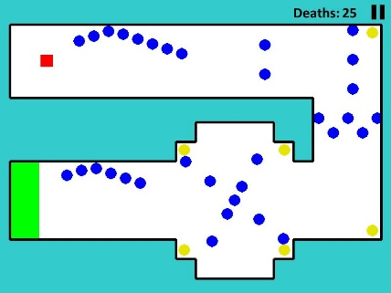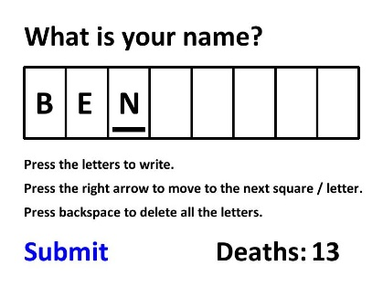This is a game that I spent a half term at my dad’s work on. It took around 30 hours to make and includes 1326 lines of code. It opens as a menu where you can pick from 3 options: Play, Instruction and Leaderboard. If you press Play it will open up level 1 when you complete that it will open up level 2 and so on until you complete level 5. Each level consists of boundaries that you can’t go out of, a red square that you move, moving blue balls that you must dodge and a yellow coin that you must collect before reaching the green finish point. It also includes a pause button that will bring you to an option page (with a resume, restart and menu buttons). Once you complete all the levels it will open a page where you should submit your name and it will save it onto a json file along with how many times you died. Then it will open the menu up again and you can view you s c ore on the leaderboard if you are in the top 5.